**Experiment 7**

**Aim:**

To write an ARM Assembly Language to multiply two numbers using repeated addition.

**Tool Used:**

Keil uVision4

**Theory:**

LDR loads the register with some value. One number can be used as counter and the other number can be decremented every loop. On every loop the 1 st number is adder on to the result.

**Code:**

 AREA PROGRAM, CODE, READONLY

 ENTRY

MAIN

    LDR R0, =0X00001000

    LDR R1, =0X00001004

    LDR R2, [R0]

    LDR R3, [R1]

LOOP

    ADD R4, R4, R2

    SUBS R3,R3,#1

    BNE LOOP

    END

**Output:**

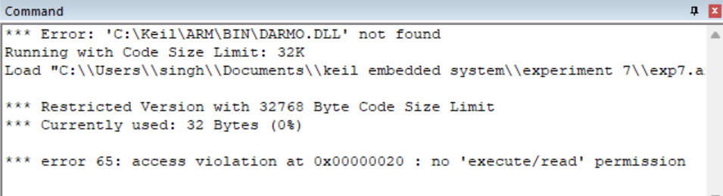

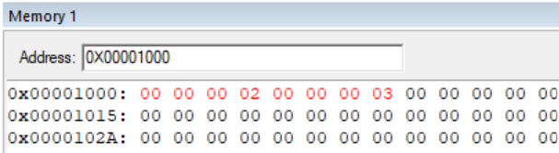

**Register Content**

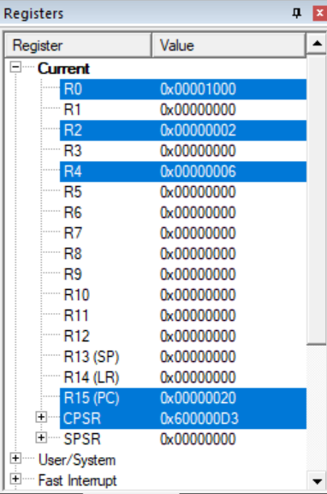

**Result:**

The experiments on multiplication operation have been performed and verified to be correct.